ICAI – Level 2 Capstone Project
Senior Scheme: Risk-Based Premium Allocation for the 2027 Renewal
Group Medical Insurance – Company Gold and Company Gold with Dental Cover
Submitted by: Pankaj Kumar
Batch: L2B119
Date: November 2026
Project folder: AICA-L2-Batch-L2B119-Pankaj-Kumar

Contents
1. Executive Summary 3
2. Background and Problem Statement 3
2.1 The Senior Scheme 3
2.2 The problem 3
3. Objectives and Scope 4
4. Data 4
5. Methodology 4
5.1 Pricing formula 4
5.2 Steps in the workbook 5
5.3 Age and rounding conventions 5
6. Factor Calibration 5
7. Results 6
7.1 By country of residence 6
7.2 By age group 7
7.3 By member category 7
7.4 With dental cover 8
7.5 Percentage increase 2027 over 2026 9
8. Model Design and Controls 9
9. Key Observations and Recommendations 10
Limitations 10
10. Conclusion 10
Appendix A – Deliverables 11
Appendix B – Tools Used 11
Appendix C – 2027 Premium by Member 11

1. Executive Summary
The insurer has renewed the Senior Scheme for 2027 with a 10% increase in total premium, from $781,000 to $859,100. Until 2026 every insured life paid the same premium – $8,000 for Company Gold and $8,500 for Company Gold with Dental Cover – regardless of where the member lives, how old they are or which member category they belong to. This produced an inequitable allocation, with lower-cost members subsidising higher-cost members.
This project replaces the flat rate with a risk-based allocation. Each member's premium is a single Company Gold base premium multiplied by four loadings: country of residence, member category, age group and dental cover. The base premium is solved so that the 96 individual premiums add up to exactly $859,100.
At management's request the country and age loadings were moderated so that the Company Gold base premium is about $6,000 and very large individual increases are avoided. The key results are:
- Total 2027 premium: $859,100 (+10.0%), reconciled to the dollar.
- Company Gold base premium: $6,001.27 (adult member, Africa or India, Employee/Family Category 1).
- Individual premiums: from $5,941 to $14,845, compared with a flat $8,000 / $8,500 in 2026.
- Distribution: 38 members pay less than in 2026 and 58 pay more; only 3 members see an increase above 50%.
- Model: fully formula-driven in Excel – changing any factor automatically recalculates every premium while keeping the total at $859,100.

2. Background and Problem Statement

2.1 The Senior Scheme
The Senior Scheme is the Group's global medical insurance scheme. It has two products, Company Gold and Company Gold with Dental Cover, and premium is charged per life. The scheme covers 96 lives across seven countries and five member categories.
Member category | Description
Family – Category 1 | Family 1 and Family 2 – direct descendants up to 3 generations, including spouses and children
Family – Category 2 | Family 1 and Family 2 members other than Category 1
Employee – Category 1 | Senior employees of the Group
Employee – Category 2 | Senior employees who left after more than 10 years' service (admission subject to approval)
Associates | All others not covered above

2.2 The problem
A uniform premium ignores three of the main drivers of medical cost:
- Country of residence – medical costs and medical inflation differ significantly between, for example, Kenya and Singapore.
- Age – claims frequency and cost rise with age; 54 of the 96 members are aged 65 or over.
- Member category – categories differ in risk profile and in the Group's policy towards subsidising them.
With the insurer requiring a 10% increase for 2027, simply adding 10% to every member would perpetuate this cross-subsidy. The renewal is therefore the right moment to move to risk-based pricing.

3. Objectives and Scope
- Calculate each member's age as at 01 January 2027 from date of birth.
- Calculate each member's 2027 premium using a Company Gold base premium loaded for country, member category, age group and dental cover, so that the total equals $859,100.
- Build the calculation so that changing any factor automatically recalculates all premiums, and show the formulas used.
- Produce the workbook "Senior Scheme-Premium for 2027", a management presentation with charts and tables, and this report.

4. Data
The source workbook "Base File – Senior Scheme.xlsx" contains two sheets:
- Senior Scheme-Basic Data – one row per insured life (rows 2–97): date of birth (column E), product (H), country of residence (J), 2026 premium (L). Member category is identified by the cell colour in columns C and D.
- Factor-Loading-Senior Scheme – loadings for country (A3:B9), member category (A12:B16, with the colour legend), age group (A19:B21) and dental cover (A24:B24).
Two data issues were resolved before calculation:
- Category stored as colour: Excel formulas cannot read cell colours, so a "Member Category" column (N) was added with the category in text, mapped from each row's colour.
- "All Countries in Africa" vs "Kenya": the data uses country names, so a country-to-factor-group mapping table was added (Factor sheet G3:H15). New countries can be added there.

5. Methodology

5.1 Pricing formula
Each member's premium is calculated as:
Premium = Base Premium × Country Factor × Category Factor × Age Factor × Dental Factor
The product of the four factors is the member's combined factor. Because the total premium is fixed by the insurer, the base premium is not chosen arbitrarily – it is solved from the data:
Base Premium = $859,100 ÷ Σ (combined factors of all 96 members) = $859,100 ÷ 143.1531 = $6,001.27
This guarantees that the individual premiums always add up to the target, whatever factors are used.

5.2 Steps in the workbook
Column | Field | Formula (row 2)
F | Age at 01/01/2027 | =DATEDIF(E2, Factor!$B$28, "y")
N | Member Category | Text, mapped from cell colour
O | Country factor group | =INDEX(Factor!$H$3:$H$15, MATCH(J2, Factor!$G$3:$G$15, 0))
P | Age group | =INDEX(Factor!$A$19:$A$21, MATCH(F2, Factor!$D$19:$D$21, 1))
Q–S | Country / Category / Age factor | =INDEX(factor column, MATCH(group, label column, 0))
T | Dental factor | =IF(H2="Company Gold with Dental Cover", Factor!$B$24, 1)
U | Combined factor | =Q2*R2*S2*T2
V | Exact premium | =Factor!$B$33*U2
M | 2027 premium | =ROUND(V2,0) + rounding adjustment on the highest-premium row
M98 | Total | =SUM(M2:M97) → $859,100
"Factor!" is shorthand for the sheet "Factor-Loading-Senior Scheme". The full list is in the workbook's "Formula Guide" sheet.

5.3 Age and rounding conventions
- Age is in completed years at 01 January 2027 (age last birthday). Ages range from 5 to 99.
- Premiums are rounded to whole dollars. Rounding leaves a difference of −$8, which is applied to the member with the highest premium so that the total is exactly $859,100. The adjustment is calculated by formula (Factor sheet B35), so it updates automatically.

6. Factor Calibration
With the factors in the original brief, the solved base premium was only $3,169 and individual premiums ranged from $3,485 to $19,169, with 17 members facing increases above 50%. Management asked whether the base premium could be kept at about $6,000 so that increases for other members would be less severe.
Because the total is fixed, rescaling all factors proportionally would raise the base but leave every member's premium almost unchanged. What reduces the extreme increases is narrowing the spread between the highest and lowest factors. The country and age factors were therefore moderated; the category and dental loadings were kept as in the brief. Age 21–64 became the reference band (1.00).
Factor | Applied
All Countries in Africa / India | 1.00
United Kingdom | 1.30
Singapore / Hong Kong | 1.50
Switzerland | 1.15
United Arab Emirates | 1.20
Age 0–20 | 0.90
Age 21–64 | 1.00
Age 65–120 | 1.20
Employee Cat 1 / Family Cat 1 | 1.00
Employee Cat 2 / Family Cat 2 | 1.10
Associates | 1.30
Dental cover | 1.25

Outcome | Applied factors
Company Gold base premium | $6,001
Lowest / highest individual premium | $5,941 / $14,845
Members with increase above 50% | 3
Singapore – change | +28%
United Kingdom – change | +18%
Kenya – change | −0.1%

7. Results
The total 2027 premium is $859,100, an increase of $78,100 (+10.0%) on 2026. The average premium per life rises from $8,135 to $8,949. The tables below show the revised premiums by each pricing dimension.

7.1 By country of residence
Country | Lives | 2026 premium | 2027 premium | Change | Avg 2027 / life
Kenya | 45 | $360,500 | $360,267 | −0.1% | $8,006
India | 3 | $24,000 | $17,883 | −25.5% | $5,961
Switzerland | 10 | $85,000 | $88,771 | +4.4% | $8,877
United Kingdom | 16 | $132,000 | $155,935 | +18.1% | $9,746
Singapore | 16 | $128,500 | $164,275 | +27.8% | $10,267
Hong Kong | 4 | $34,000 | $43,883 | +29.1% | $10,971
United Arab Emirates | 2 | $17,000 | $28,086 | +65.2% | $14,043
Total | 96 | $781,000 | $859,100 | +10.0% | $8,949
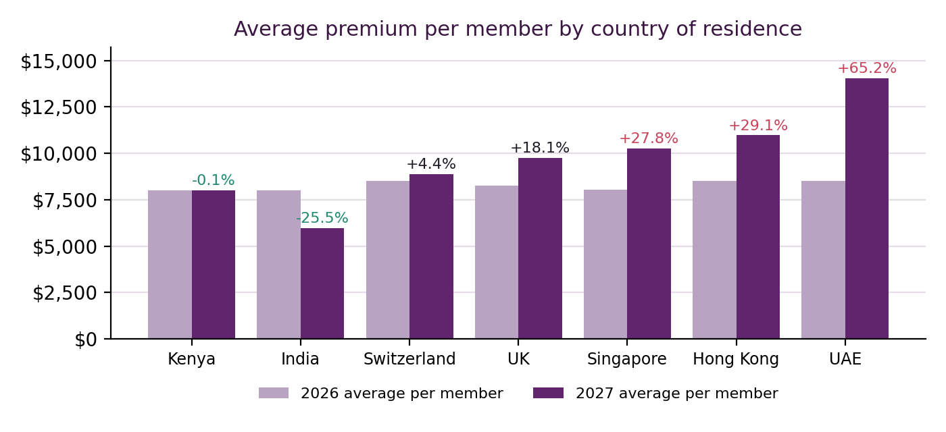
Kenya, which accounts for almost half of the lives, is essentially unchanged. Increases are concentrated in the high-cost locations of Singapore (+27.8%), Hong Kong (+29.1%) and the UAE (+65.2%). Both UAE members are Associates aged 65+ with dental cover, so three loadings combine. India, with the lowest factor and three members (two of them under 21), sees a reduction of 25.5%.

7.2 By age group
Age group (years) | Lives | 2026 premium | 2027 premium | Change | Avg 2027 / life
0-20 | 7 | $58,000 | $54,990 | −5.2% | $7,856
21-64 | 35 | $286,500 | $301,717 | +5.3% | $8,620
65-120 | 54 | $436,500 | $502,393 | +15.1% | $9,304
Total | 96 | $781,000 | $859,100 | +10.0% | $8,949
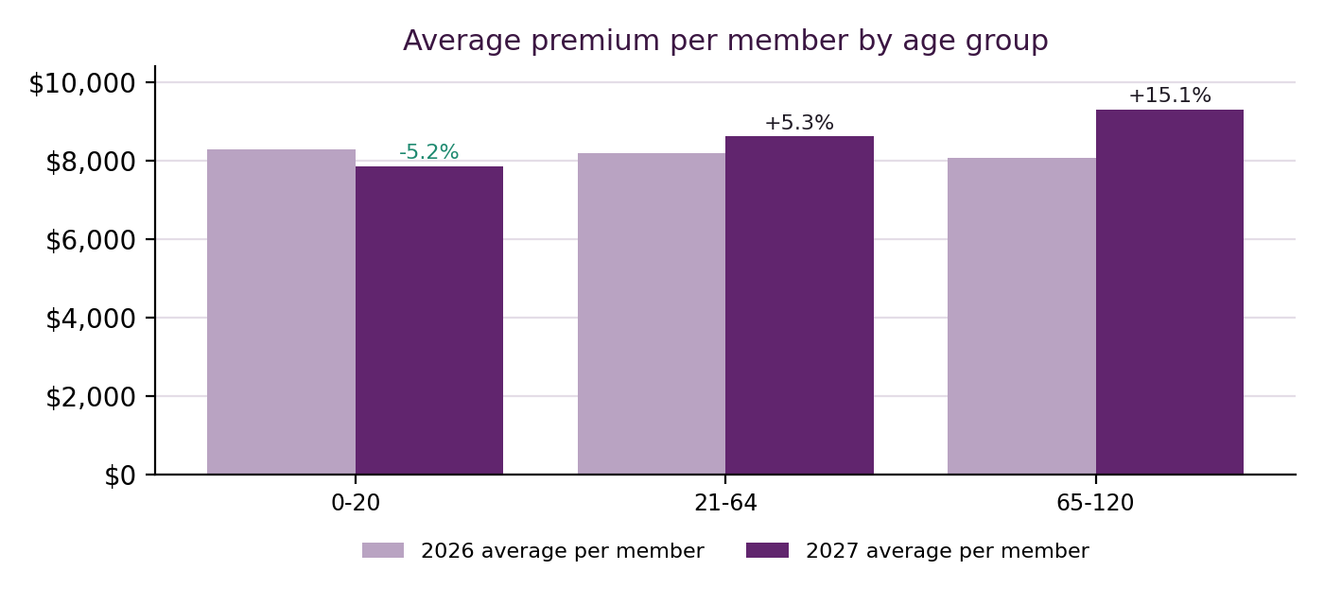
Members aged 65 and over, who represent 56% of the lives, bear most of the increase (+15.1%), consistent with their higher expected claims. Members under 21 pay 5.2% less.

7.3 By member category
Member category | Lives | 2026 premium | 2027 premium | Change | Avg 2027 / life
Employee - Category 1 | 8 | $66,000 | $78,091 | +18.3% | $9,761
Employee - Category 2 | 6 | $48,500 | $53,134 | +9.6% | $8,856
Family - Category 1 | 51 | $415,500 | $449,312 | +8.1% | $8,810
Family - Category 2 | 6 | $50,000 | $51,532 | +3.1% | $8,589
Associates | 25 | $201,000 | $227,031 | +13.0% | $9,081
Total | 96 | $781,000 | $859,100 | +10.0% | $8,949
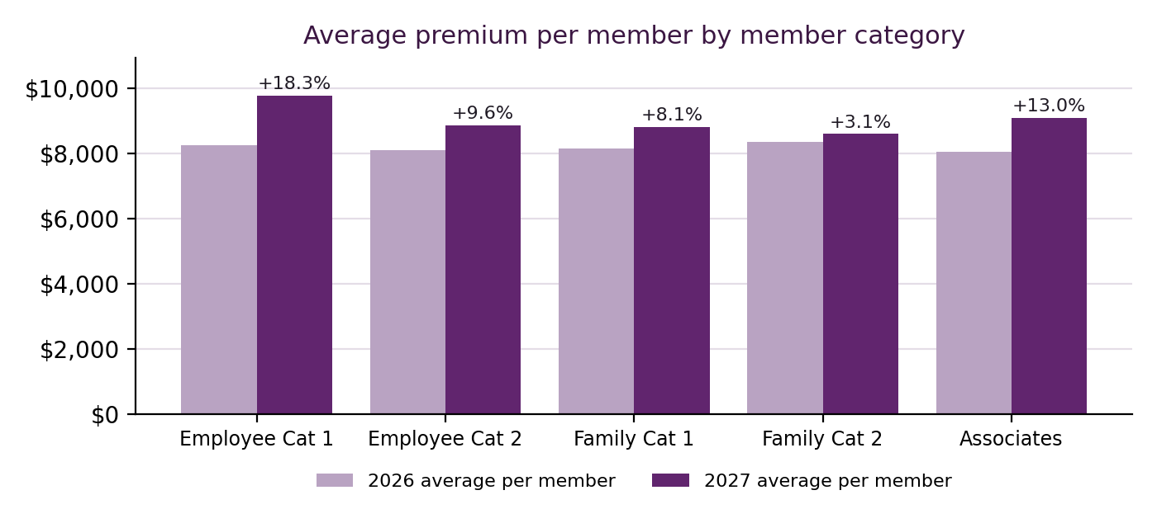
Category results reflect country and age as well as the category loading. Employee Category 1 rises 18.3% despite a loading of 1.00 because most of these members live in the UK, Switzerland or Singapore. Associates, with the highest loading (1.30), rise 13.0%.

7.4 With dental cover
Product | Lives | 2026 premium | 2027 premium | Change | Avg 2027 / life
Company Gold | 70 | $560,000 | $588,794 | +5.1% | $8,411
Company Gold with Dental Cover | 26 | $221,000 | $270,306 | +22.3% | $10,396
Total | 96 | $781,000 | $859,100 | +10.0% | $8,949
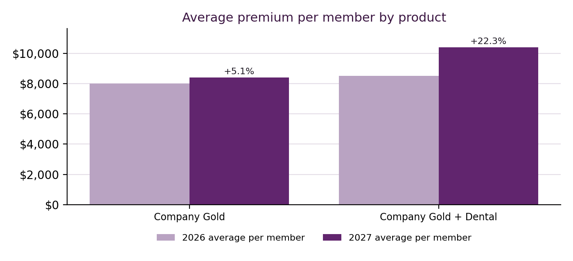
Under the 2026 structure, dental cover cost only $500 (6.25%) more than Company Gold. Applying the 25% dental loading – and the fact that dental members are concentrated in higher-cost countries – increases the dental product by 22.3%, against 5.1% for Company Gold only.

7.5 Percentage increase 2027 over 2026
% change band | Members
Down >20% | 4
Down 0–20% | 34
Up 0–10% | 8
Up 10–25% | 31
Up 25–50% | 16
Up >50% | 3
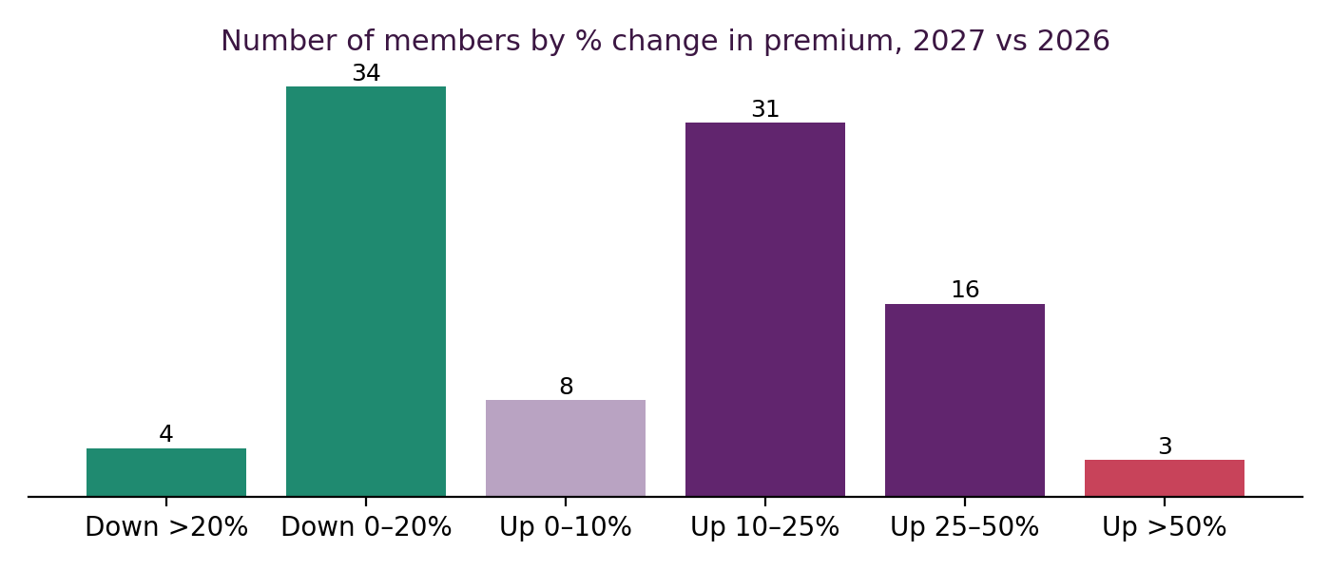
38 members pay less in 2027 and 58 pay more. The three members above +50% are the two UAE members (+65.2%) and a Singapore resident aged 90 with dental cover (+74.6%, from $8,500 to $14,845).

8. Model Design and Controls
- Inputs clearly marked: all factors, age bands, the valuation date and the insurer's increase are blue-on-yellow input cells on the Factor sheet; the original brief factors are shown beside them for reference.
- No hard-coded results: every premium, the base premium and all summary tables are formulas.
- Built-in checks: M100 (and Factor sheet B37) show calculated total minus target, which must be zero.
- Recalculation tested: setting Singapore back to 2.20 and age 65+ to 2.00 changed the base premium to $3,959 and redistributed premiums, while the total stayed at $859,100.
- Summary sheet: premium by country, age group, category and product, with charts, all linked to the data sheet.

9. Key Observations and Recommendations
- Adopt the risk-based structure with the moderated factors for the 2027 renewal. It meets the insurer's total exactly while allocating cost more fairly.
- Consider transitional relief for the three members above +50% (for example, a one-year cap), funded within the scheme total.
- Communicate early with members in the UK, Singapore, Hong Kong and UAE, explaining the drivers of their change.
- Review factors annually against actual claims experience and country medical-inflation data, moving gradually towards the full loadings in the original brief if justified.
- Record member category as data in the membership system rather than as cell colour, to reduce manual risk.

Limitations
Factors are management assumptions and have not been validated against claims data. The scheme is small (96 lives), so results for groups such as UAE (2) and India (3) are sensitive to individual members.

10. Conclusion
The project delivers a transparent, formula-driven premium model that meets the insurer's 2027 total of $859,100, sets the Company Gold base premium at about $6,000, and links each member's premium to the main drivers of medical cost. The model allows management to test alternative factors instantly while the total remains reconciled.

Appendix A – Deliverables
File | Content
Senior Scheme-Premium for 2027.xlsx | Calculation workbook: Basic Data (ages and 2027 premiums), Factor sheet, Summary with charts, Formula Guide
Senior Scheme-2027 Premium Review (Presentation).pptx | 11-slide presentation for senior management
Senior Scheme-2027 Premium Project Report.docx | This report
01_Inputs folder | Original base file and project brief

Appendix B – Tools Used
Microsoft Excel (formulas: DATEDIF, INDEX/MATCH, ROUND, SUMPRODUCT, SUMIF/COUNTIF); Python with openpyxl and matplotlib for building and verifying the workbook and charts; an AI assistant (Claude) for drafting, analysis and building the deliverables.

Appendix C – 2027 Premium by Member
Member | Age | Country | Category | Product | 2026 | 2027 | Change
1 | 54 | UK | Fam Cat 1 | Gold + Dental | $8,500 | $9,752 | +14.7%
2 | 27 | UK | Fam Cat 2 | Gold + Dental | $8,500 | $10,727 | +26.2%
3 | 25 | UK | Fam Cat 2 | Gold + Dental | $8,500 | $10,727 | +26.2%
4 | 19 | UK | Fam Cat 2 | Gold + Dental | $8,500 | $9,655 | +13.6%
5 | 54 | UK | Fam Cat 1 | Gold + Dental | $8,500 | $9,752 | +14.7%
6 | 80 | UK | Fam Cat 1 | Gold + Dental | $8,500 | $11,702 | +37.7%
7 | 48 | Switzerland | Fam Cat 1 | Gold + Dental | $8,500 | $8,627 | +1.5%
8 | 5 | Switzerland | Fam Cat 2 | Gold + Dental | $8,500 | $8,541 | +0.5%
9 | 42 | Switzerland | Fam Cat 1 | Gold + Dental | $8,500 | $8,627 | +1.5%
10 | 57 | Switzerland | Fam Cat 1 | Gold + Dental | $8,500 | $8,627 | +1.5%
11 | 23 | Switzerland | Fam Cat 1 | Gold + Dental | $8,500 | $8,627 | +1.5%
12 | 20 | Switzerland | Fam Cat 1 | Gold + Dental | $8,500 | $7,764 | −8.7%
13 | 56 | Switzerland | Fam Cat 1 | Gold + Dental | $8,500 | $8,627 | +1.5%
14 | 64 | UK | Fam Cat 1 | Gold | $8,000 | $7,802 | −2.5%
15 | 32 | UK | Fam Cat 1 | Gold | $8,000 | $7,802 | −2.5%
16 | 66 | UK | Fam Cat 1 | Gold | $8,000 | $9,362 | +17.0%
17 | 59 | UK | Fam Cat 1 | Gold | $8,000 | $7,802 | −2.5%
18 | 97 | Kenya | Fam Cat 1 | Gold | $8,000 | $7,202 | −10.0%
19 | 92 | Kenya | Fam Cat 1 | Gold | $8,000 | $7,202 | −10.0%
20 | 65 | Kenya | Fam Cat 1 | Gold + Dental | $8,500 | $9,002 | +5.9%
21 | 66 | Kenya | Fam Cat 1 | Gold | $8,000 | $7,202 | −10.0%
22 | 71 | Kenya | Fam Cat 1 | Gold | $8,000 | $7,202 | −10.0%
23 | 65 | Kenya | Fam Cat 1 | Gold | $8,000 | $7,202 | −10.0%
24 | 80 | Switzerland | Fam Cat 1 | Gold + Dental | $8,500 | $10,352 | +21.8%
25 | 50 | Switzerland | Fam Cat 1 | Gold + Dental | $8,500 | $8,627 | +1.5%
26 | 84 | Switzerland | Fam Cat 1 | Gold + Dental | $8,500 | $10,352 | +21.8%
27 | 65 | Singapore | Fam Cat 1 | Gold | $8,000 | $10,802 | +35.0%
28 | 28 | Singapore | Fam Cat 1 | Gold | $8,000 | $9,002 | +12.5%
29 | 27 | Singapore | Fam Cat 1 | Gold | $8,000 | $9,002 | +12.5%
30 | 60 | Singapore | Fam Cat 1 | Gold | $8,000 | $9,002 | +12.5%
31 | 88 | Singapore | Fam Cat 1 | Gold | $8,000 | $10,802 | +35.0%
32 | 86 | Singapore | Fam Cat 1 | Gold | $8,000 | $10,802 | +35.0%
33 | 99 | Singapore | Fam Cat 1 | Gold | $8,000 | $10,802 | +35.0%
34 | 69 | Singapore | Fam Cat 1 | Gold | $8,000 | $10,802 | +35.0%
35 | 33 | Singapore | Fam Cat 1 | Gold | $8,000 | $9,002 | +12.5%
36 | 37 | Singapore | Fam Cat 1 | Gold | $8,000 | $9,002 | +12.5%
37 | 68 | Singapore | Fam Cat 1 | Gold | $8,000 | $10,802 | +35.0%
38 | 63 | Singapore | Fam Cat 1 | Gold | $8,000 | $9,002 | +12.5%
39 | 65 | Singapore | Fam Cat 1 | Gold | $8,000 | $10,802 | +35.0%
40 | 47 | India | Fam Cat 1 | Gold | $8,000 | $6,001 | −25.0%
41 | 8 | India | Fam Cat 2 | Gold | $8,000 | $5,941 | −25.7%
42 | 5 | India | Fam Cat 2 | Gold | $8,000 | $5,941 | −25.7%
43 | 78 | UK | Fam Cat 1 | Gold + Dental | $8,500 | $11,702 | +37.7%
44 | 77 | UK | Fam Cat 1 | Gold + Dental | $8,500 | $11,702 | +37.7%
45 | 82 | UK | Fam Cat 1 | Gold | $8,000 | $9,362 | +17.0%
46 | 76 | UK | Fam Cat 1 | Gold | $8,000 | $9,362 | +17.0%
47 | 85 | UK | Fam Cat 1 | Gold | $8,000 | $9,362 | +17.0%
48 | 80 | UK | Fam Cat 1 | Gold | $8,000 | $9,362 | +17.0%
49 | 84 | Kenya | Fam Cat 1 | Gold | $8,000 | $7,202 | −10.0%
50 | 79 | Kenya | Fam Cat 1 | Gold | $8,000 | $7,202 | −10.0%
51 | 81 | Kenya | Fam Cat 1 | Gold | $8,000 | $7,202 | −10.0%
52 | 63 | Kenya | Fam Cat 1 | Gold | $8,000 | $6,001 | −25.0%
53 | 75 | Kenya | Fam Cat 1 | Gold | $8,000 | $7,202 | −10.0%
54 | 69 | Kenya | Fam Cat 1 | Gold | $8,000 | $7,202 | −10.0%
55 | 95 | Kenya | Fam Cat 1 | Gold | $8,000 | $7,202 | −10.0%
56 | 78 | Kenya | Fam Cat 1 | Gold | $8,000 | $7,202 | −10.0%
57 | 76 | Kenya | Fam Cat 1 | Gold | $8,000 | $7,202 | −10.0%
58 | 90 | Singapore | Emp Cat 2 | Gold + Dental | $8,500 | $14,845 | +74.6%
59 | 74 | Kenya | Emp Cat 1 | Gold | $8,000 | $7,202 | −10.0%
60 | 70 | Kenya | Emp Cat 1 | Gold | $8,000 | $7,202 | −10.0%
61 | 67 | Singapore | Emp Cat 1 | Gold | $8,000 | $10,802 | +35.0%
62 | 64 | Singapore | Emp Cat 1 | Gold | $8,000 | $9,002 | +12.5%
63 | 59 | Hong Kong | Emp Cat 1 | Gold + Dental | $8,500 | $11,252 | +32.4%
64 | 18 | Hong Kong | Emp Cat 1 | Gold + Dental | $8,500 | $10,127 | +19.1%
65 | 55 | Hong Kong | Emp Cat 1 | Gold + Dental | $8,500 | $11,252 | +32.4%
66 | 51 | Hong Kong | Emp Cat 1 | Gold + Dental | $8,500 | $11,252 | +32.4%
67 | 90 | Kenya | Emp Cat 2 | Gold | $8,000 | $7,922 | −1.0%
68 | 86 | Kenya | Emp Cat 2 | Gold | $8,000 | $7,922 | −1.0%
69 | 71 | Kenya | Emp Cat 2 | Gold | $8,000 | $7,922 | −1.0%
70 | 69 | Kenya | Emp Cat 2 | Gold | $8,000 | $7,922 | −1.0%
71 | 59 | Kenya | Emp Cat 2 | Gold | $8,000 | $6,601 | −17.5%
72 | 61 | Kenya | Associates | Gold | $8,000 | $7,802 | −2.5%
73 | 61 | Kenya | Associates | Gold | $8,000 | $7,802 | −2.5%
74 | 76 | Kenya | Associates | Gold | $8,000 | $9,362 | +17.0%
75 | 67 | Kenya | Associates | Gold | $8,000 | $9,362 | +17.0%
76 | 83 | Kenya | Associates | Gold | $8,000 | $9,362 | +17.0%
77 | 82 | Kenya | Associates | Gold | $8,000 | $9,362 | +17.0%
78 | 74 | Kenya | Associates | Gold | $8,000 | $9,362 | +17.0%
79 | 41 | Kenya | Associates | Gold | $8,000 | $7,802 | −2.5%
80 | 82 | Kenya | Associates | Gold | $8,000 | $9,362 | +17.0%
81 | 76 | Kenya | Associates | Gold | $8,000 | $9,362 | +17.0%
82 | 53 | Kenya | Associates | Gold | $8,000 | $7,802 | −2.5%
83 | 62 | Kenya | Associates | Gold | $8,000 | $7,802 | −2.5%
84 | 67 | Kenya | Associates | Gold | $8,000 | $9,362 | +17.0%
85 | 37 | Kenya | Associates | Gold | $8,000 | $7,802 | −2.5%
86 | 36 | Kenya | Associates | Gold | $8,000 | $7,802 | −2.5%
87 | 72 | Kenya | Associates | Gold | $8,000 | $9,362 | +17.0%
88 | 60 | Kenya | Associates | Gold | $8,000 | $7,802 | −2.5%
89 | 19 | Kenya | Associates | Gold | $8,000 | $7,021 | −12.2%
90 | 59 | Kenya | Associates | Gold | $8,000 | $7,802 | −2.5%
91 | 75 | Kenya | Associates | Gold | $8,000 | $9,362 | +17.0%
92 | 75 | Kenya | Associates | Gold | $8,000 | $9,362 | +17.0%
93 | 91 | Kenya | Associates | Gold | $8,000 | $9,362 | +17.0%
94 | 91 | Kenya | Associates | Gold | $8,000 | $9,362 | +17.0%
95 | 75 | UAE | Associates | Gold + Dental | $8,500 | $14,043 | +65.2%
96 | 71 | UAE | Associates | Gold + Dental | $8,500 | $14,043 | +65.2%

